Table of Contents

- Test Fixture Kit TX-4004-CT102S-4GES Disassembly
- Drilling and Milling of Test Fixture Panels
- AC Entry Module Cover and Bracket Fabrication
- Assembly of Cables
- Modification of Panel Mount USB Adapter Module
- Fabrication of 26-pin Adapter PWA
- Installation of Test Fixture Base Sub-assemblies
- Test Fixture Base, Assembly Instructions
- Wiring of Test Fixture Base Modules
- Probe Plate Reassembly
- Installation of Probe Sockets and Alignment Pins
- Wiring of Probe Sockets
- Stripper Plate Reassembly
- Installing CAM Over-clamp Assembly to Test Fixture Base
- Fixture Engagement Switch Adjustment
- AC Entry Module Cover Installation

List of Figures

Figure 1. Test Fixture Kit View
Figure 2. Gas Hinge Removal
Figure 3. CAM Over-clamp Hinge Screw Locations
Figure 4. Push Plate View
Figure 5. Latch Lock Screw Locations
Figure 6. CAM Screw Locations
Figure 7. Push Plate Spring Assembly Screw Locations
Figure 8. Lexan Push Plate
Figure 9. Stripper Plate View
Figure 10. Stripper Plate Removal
Figure 11. Latch Block Removal
Figure 12. Hinge Block Removal
Figure 13. Gas Hinge Block Removal
Figure 14. Shipping Screw Location
Figure 15. Probe Plate Hinge Screw Location
Figure 16. Probe Plate Latch Screw Location
Figure 17. Probe Plate Spring Hinge Screw Location
Figure 18. Probe Plate View
Figure 19. Test Fixture Base View
Figure 20. Left Side Probe Plate Spring Hinge Removal
Figure 21. Rear Support Bar and Rear Probe Plate Hinge Locations
Figure 22. Bottom Panel Drilling Detail
Figure 23. Rear Panel Drilling/Milling Detail
Figure 24. Front Panel Drilling Detail
Figure 25. Marking of Angle Aluminum Stock
Figure 26. Notching Angle Aluminum Bracket
Figure 27. Residual Material View
Figure 28. AC Entry Module Bracket View
Figure 29. Marking Pilot Holes for AC Entry Module Bbracket
Figure 30. AC Entry Module Cover and Bracket Fabrication Detail
Figure 31. Switch Mounting Bracket Detail
Figure 32. Fourteen Inch 26-pin Ribbon Cable View
Figure 33 Ten Inch 26-pin Ribbon Cable View
Figure 34. AC Entry Module Input Cables
Figure 35. Power Module Output Cable
Figure 36. Modification of USB Adapter Module
Figure 37. 26-pin Adapter PWA
Figure 38. Drilled Bottom Panel View
Figure 39. Assembled Bottom Panel
Figure 40. Assembled Rear Panel
Figure 41. Assembled Front Panel
Figure 42. Flash Drive USB connections
Figure 43. J25 USB HUB connections
Figure 44. 26-pin Ribbon Cable Installation, Adapter PWA to Probe Sockets

1.0 Test Fixture Kit TX-4004-CT102S-4GES Disassembly
Note: to ease reassembly process, bin and mark hardware with each subassembly being removed.

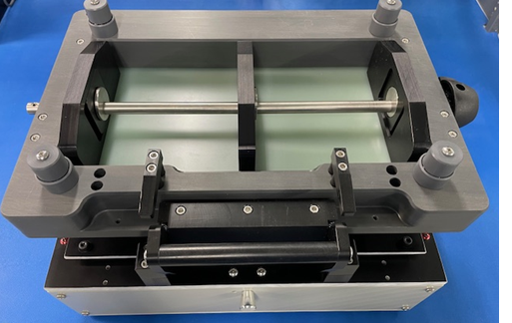
Figure 1. Test Fixture Kit View

1.1 Removal of CAM over-clamp assembly

1.1.1 Loosen clip on both gas hinges and remove from ball joint (do not remove clip). Note: the ball joint has grease for lubrication.

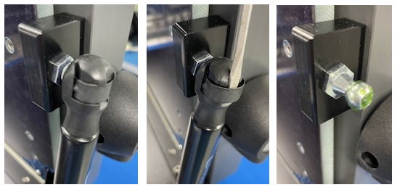
Figure 2. Gas Hinge Removal

1.1.2 Remove 4 screws securing CAM over-clamp assembly to hinges.

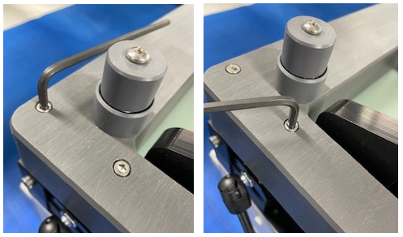
Figure 3. CAM Over-clamp Hinge Screw Locations

1.1.3 Place CAM over-clamp assembly upside down to remove push plate.

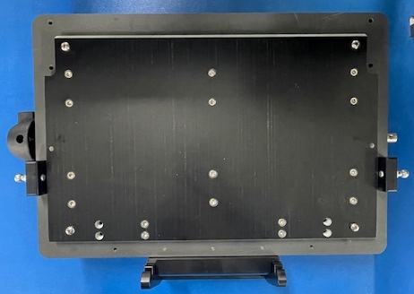
Figure 4. Push Plate View

1.2 Push plate removal

1.2.1 Remove 2 latch locks.
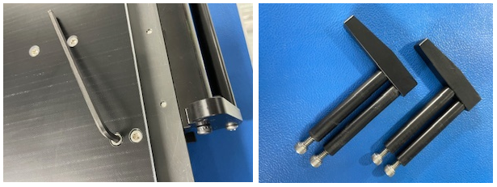
Figure 5. Latch Lock Screw Locations

1.2.2 Remove screws from 3 CAM assemblies (12 screws).
Note: Observe CAM positioning as reference for re-assembly.

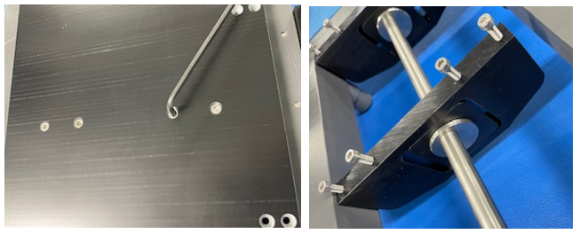
Figure 6. CAM Screw Locations

1.2.3 Remove push plate spring assembly screws.

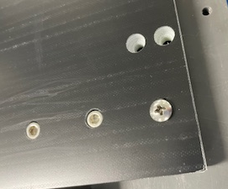
Figure 7. Push Plate Spring Assembly Screw Locations

1.2.4 Remove push plate and replace it with Lexan push plate after drilling.

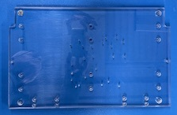
Figure 8. Lexan Push Plate

1.3 Stripper plate removal

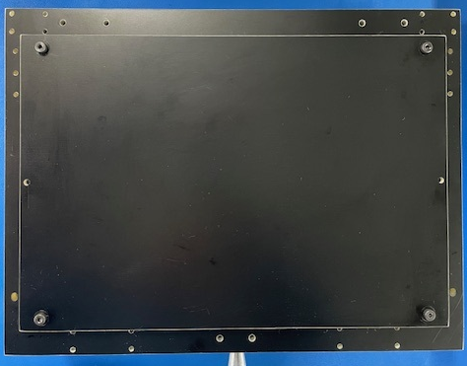
Figure 9. Stripper Plate View

1.3.1 Remove 4 knurled screws from stripper plate, then remove 6 springs.

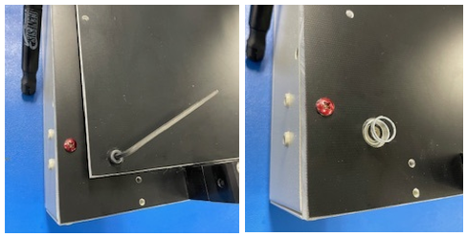
Figure 10. Stripper Plate Removal

1.4 Probe plate removal

1.4.1 Remove 2 latch blocks.
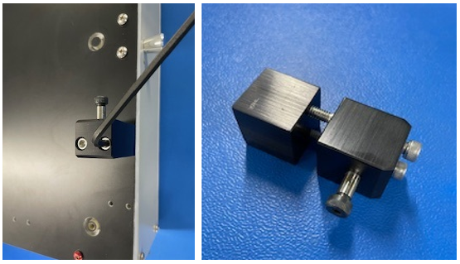
Figure 11. Latch Block Removal

1.4.2 Remove 2 hinge blocks.

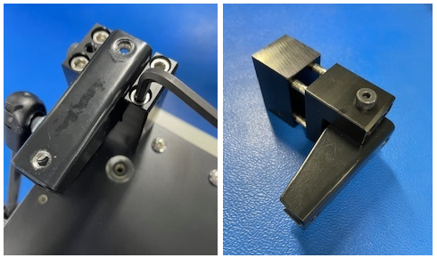
Figure 12. Hinge Block Removal

1.4.3 Remove 2 gas hinge blocks.

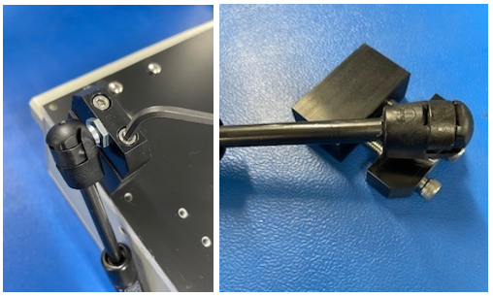
Figure 13. Gas Hinge Block Removal

1.4.4 Remove shipping screws.

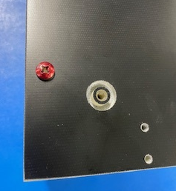
Figure 14. Shipping Screw Location

1.4.5 Remove rear probe plate hinge screws.
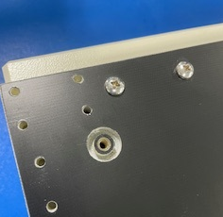
Figure 15. Probe Plate Hinge Screw Location

1.4.6 Remove probe plate latch.

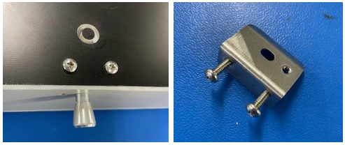
Figure 16. Probe Plate Latch Screw Location

1.4.7 Remove probe plate spring hinges from probe plate.

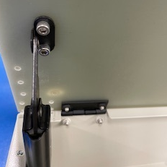
Figure 17. Probe Plate Spring Hinge Screw Location

1.4.8 Remove probe plate.

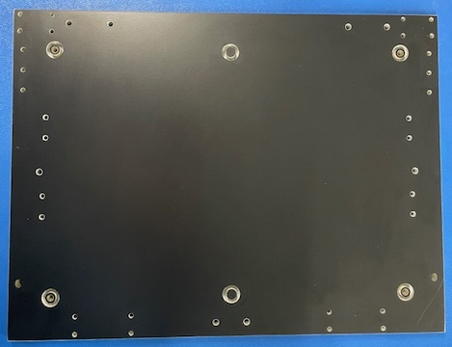
Figure 18. Probe Plate View

1.4.9 Remove any film covering from push plate, stripper plate, and probe plate.

1.6 Test fixture base disassembly instructions

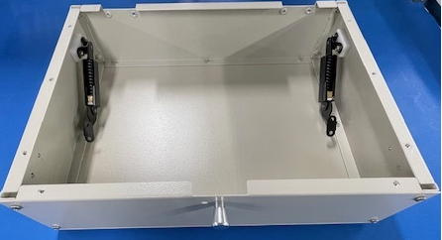
Figure 19. Test Fixture Base View

1.6.1 Remove left side probe plate spring hinge from test fixture base.
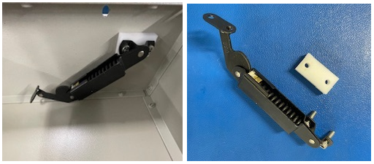
Figure 20. Left Side Probe Plate Spring Hinge Removal

1.6.1 Remove rear support bar and rear probe plate hinges.

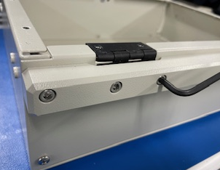
Figure 21. Rear Support Bar and Rear Probe Plate Hinge Locations

1.6.2 Remove 12 bottom panel screws.

1.6.3 Remove remaining rear panel screws.

1.6.4 Remove 4 front panel screws.

2.0 Drilling and Milling of Test Fixture Panels

2.1 Drill probe plate per drawing Drill-M1-3200-1.

2.2 Drill stripper plate per drawing Drill-M1-3200-2.

2.3 Drill push plate per drawing Drill-M1-3200-3.

2.4 Drill bottom panel per drawing TE-M1-3200-4.

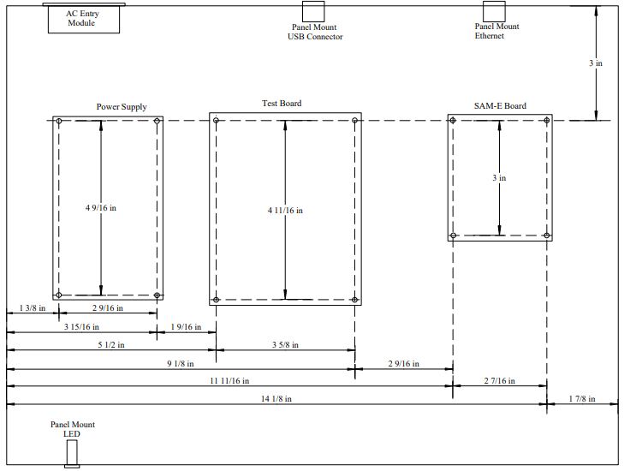
Figure 22. Bottom Panel Drilling Detail

2.5 Drill and mill rear panel per drawing TE-M1-3200-3.
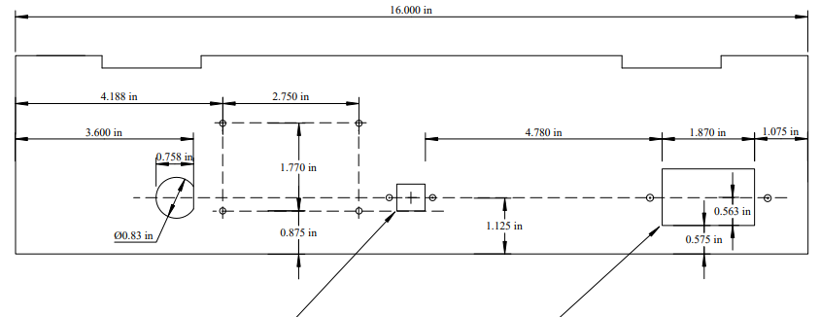
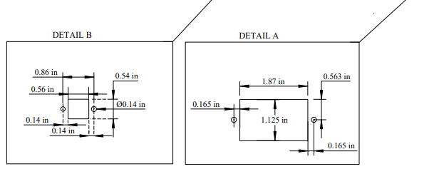
Figure 23. Rear Panel Drilling/Milling Detail

2.6 Drill front panel per drawing TE-M1-3200-2.

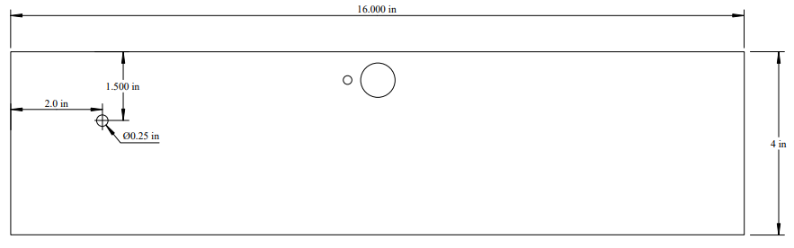
Figure 24. Front Panel Drilling Detail

3.0 AC Entry Module Cover and Bracket Fabrication

3.1 Fabricate AC entry module cover and AC entry module cover-bracket as follows.

3.1.1 Cut 1/8” G10/FR4 sheet to 3-1/2” x 2-3/8.

3.1.2 Cut 1/16” x1/2” aluminum angle stock to 6” length.

3.1.3 Measure and mark 2.35” & 2.40” from left end.
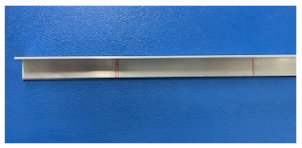
Figure 25. Marking of Angle Aluminum Stock

3.1.4 Cut a 90-degree notch using angle cutter at 2.35” mark.
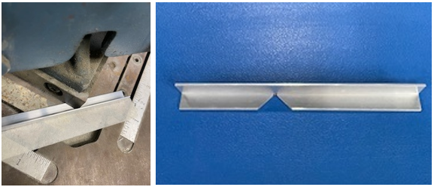
Figure 26. Notching Angle Aluminum Bracket

3.1.5 Cut 2nd notch at 2.40” mark. File the residual material between the cuts.

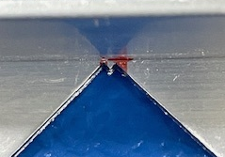
Figure 27. Residual Material View

3.1.6 Using a press brake, bend the backet to 90 degrees.
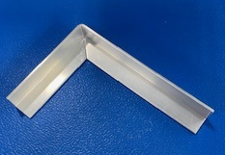
Figure 28. AC Entry Module Bracket View

3.1.7 Drill 0.054”” holes per drawing TE-M1-3200-5.

3.1.8 Temporarily install AC entry module into rear panel using 4-40 3/8” flathead screws, #4 washers, and 4-40 nuts.

3.1.9 Temporarily assemble bottom panel rear panel and left side panel together.

3.1.10 Position AC entry mounting bracket above AC entry module and mark 3 holes for drilling rear and side panels.

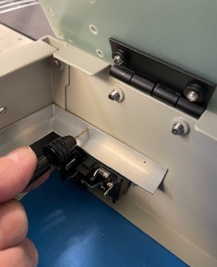
Figure 29. Marking Pilot Holes for AC Entry Module Bracket

3.1.11 Disassemble bottom panel rear panel and left side panels.

3.1.12 Drill 0.054” pilot holes at marked location on rear and left side panels.

3.1.13 Enlarge holes to 9/64” in rear and left side panels and in AC entry module bracket.

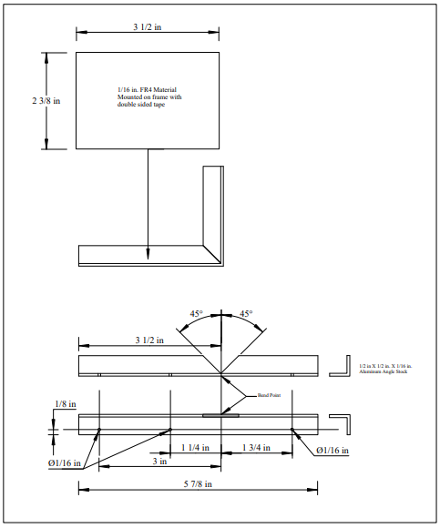
Figure 30. AC Entry Module Cover and Bracket Fabrication Detail

3.2 Fabricate switch mounting bracket per drawing TE-M1-3200-5.

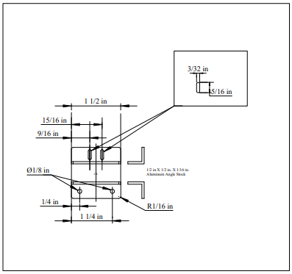
Figure 31. Switch Mounting Bracket Detail

3.2.1 Cut 1/16” x1/2” aluminum angle stock to 1-1/2” length.

3.2.2 Drill 1/8” holes at ¼” and 1-1/4” from one end.

3.2.3 On other surface, drill 3/32” holes at 9/16” and 15/16” from one end, and slot them to 5/16”.

4.0 Assembly of Cables

4.1 26-pin ribbon cable from S2 Test PWA to 26-pin adapter PWA

4.1.1 Cut 26 conductor ribbon cable to 14” long.

4.1.2 Attach 26-pin connectors, TE Connectivity P/N 1658620-6 or equivalent, as shown in Figure 32. Make sure connector keying matches the figure.

4.1.3 Bend to a right angle at the cable mid-point, as shown in Figure 32.

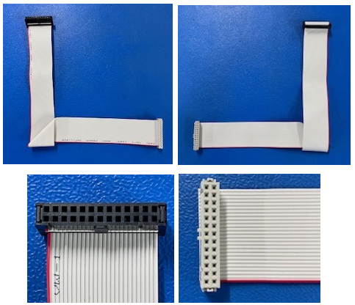
Figure 32. Fourteen Inch 26-pin Ribbon Cable View

4.2 26-pin ribbon cable from 26-pin adapter PWA to J05 wire-wrap sockets

4.2.1 Cut 26 conductor ribbon cable to 10” long.

4.2.2 Attach 26-pin connectors, TE Connectivity P/N 1658620-6 or equivalent, as shown in Figure 33. Make sure connector keying matches the figure.

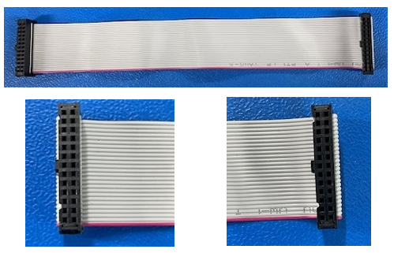
Figure 33. Ten Inch 26-pin Ribbon Cable View

4.3 AC entry module cables

4.3.1 Cut 6” lengths of black, white, and green AWG 18 wire, and strip 1/4” insulation from one end of each wire.

4.3.2 Crimp 0.187 female disconnect tab lugs, Ace Hardware P/N 3015393 or equivalent, onto the white and black wires; crimp ring lug, McMaster Carr P/N 7113K35 or equivalent, onto the green wire.

4.3.3 Crimp connector contacts, Molex P/N 0008500106, onto the other end of each wire.

4.3.4 Insert the connector contacts into the connector housing, Molex P/N 0009503051 as follows:

Pin 1, green wire
Pin 2, white wire
Pin 3, black wire

4.3.3 Cut 4” length of green AWG 18 wire, and strip ¼” insulation from both ends.

4.3.4 Crimp 0.187 female disconnect tab lugs onto one end and ring lug onto the other end.

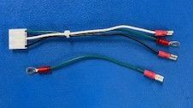
Figure 34. AC Entry Module Input Cables

4.4 Power module output cable

4.4.1 Cut one each 11” and 16” black AWG 18 wire, and strip 1/4” insulation from both ends.

4.4.2 Cut one each 10” and 15” red AWG 18 wire, and strip 1/4” insulation from both ends.

4.4.3 Crimp contact, Molex P/N 0008500106 to one end of each wire.

4.3.4 Insert the connector contacts into the connector housing, Molex P/N 0009503131 as follows:

Pin 1, red 15” wire
Pin 4, red 10” wire
Pin 7, black 16” wire
Pin 9, black 11” wire

4.4.5 Crimp contact, TE Connectivity P/N 61117-2 to other end each of 16” black and 15” red wires.

4.4.6 Insert the connector contacts into the connector housing, TE Connectivity P/N 1-480424-0, as follows:

Pin 2, black 16” wire
Pin 4, red 15” wire

4.4.7 Loosen contact screws on 2 pin connector, Adam Tech, P/N EBKA-02-A.

4.4.8 Insert the other end of the 11” black wire into the left pin location and tighten the contact screw (see Figure 35).

4.4.9 Insert the other end of the 10” red wire into the right pin location and tighten the contact screw.

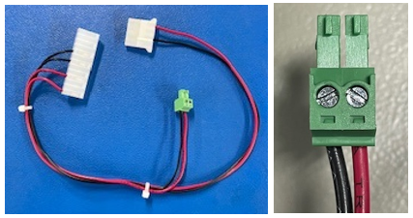
Figure 35. Power Module Output Cable

4.5 Ethernet cable, SAM-E to J11 probe sockets

4.5.1 Cut Ethernet cable, Cables2Go P/N 00392, to 12”.

4.5.2 Strip back sleeving 1”.

4.5.4 Strip 1/4” insulation from each wire.

4.5.5 Splice 5” of wire-wrap wire to each cable wire.

4.5.5 Cut 3/4” length of 1/16” diameter heat-shrink tubing for each wire, and shrink over splices.

4.6 USB COM cable

4.6.1 Cut USB cable, Cables2Go P/N54171, to 24”.

4.5.2 Strip back sleeving 1”.

4.5.4 Strip 1/4” insulation from each wire.

4.5.5 Splice 6” of wire-wrap wire to each cable wire.

4.5.5 Cut 3/4” length of 1/16” diameter heat-shrink tubing for each wire and shrink over splices.

4.6 Panel LED cable

4.6.1 Cut two 15” lengths of wire-wrap wire.

4.6.2 Strip 1/4” of insulation from each wire.

4.6.3 Solder a wire to each contact of connector, TE Connectivity P/N 3-6400442-2.

4.7 Tamper cable

4.7.1 Cut two 15” lengths of wire-wrap-wire.

4.7.2 Strip 1/4” of insulation from each wire.

4.7.3 Solder a wire to each contact of connector, TE Connectivity P/N 3-6400442-2.

4.8 Battery Cable for S2 Test PWA, J11

4.8.1 Cut two 15” lengths of wire-wrap-wire.

4.8.2 Strip 1/4” insulation from each wire.

4.8.3 Loosen the screw terminal on each contact of 2 pin connector, Pheonix Contact P/N 5435721.

4.8.4 Insert a wire-wrap wire into each contact location and tighten the terminal screws.

4.9 Power Cable for S2 Test PWA, J10

4.9.1 Cut two 15” lengths of wire-wrap-wire.

4.9.2 Strip 1/4” insulation from each wire.

4.9.3 Loosen the screw terminal on each contact of 2 pin connector, P/N 5441980.

4.9.4 Insert a wire-wrap wire into each contact location and tighten the terminal screws.

4.10 Panel mount LED

4.10.1 Strip 1/4” insulation from red and black wires.

4.10.2 splice 12” of black 26 AWG wire onto black LED wire.

4.10.3 Cut 1/2” length of 1/4” diameter heat-shrink tubing and shrink over splice.

4.10.4 Crimp Molex P/N 0008500106 contact onto end of red LED wire.

4.11 Switch wire extension

4.11.1 Cut red wire at the base of switch, Omron P/N DS2W-3L2MS.

4.11.2 Seal the cut wire with red insulating varnish, MG Chemicals P/N 4228-55ML Allow to dry.

4.11.3 Strip 1/4” insulation from remaining 2 wires.

4.11.4 Splice 6” of wire-wrap wire onto both wires.

4.11.5 Cut 1/2” length of 1/4” diameter heat-shrink tubing and shrink over splices.

5.0 Modification of Panel Mount USB Adapter Module

5.1 On panel mount USB adapter module, Amphenol P/N MUSBDA1130, cut 2 traces at locations shown in Figure 36.

5.2 Add jumper wires at locations shown in Figure 36.

5.3 On the bottom side of the USB adapter module, solder USB connector, TE Connectivity P/N 292303-4.

5.4 Secure the USB connector with a small tie wrap.

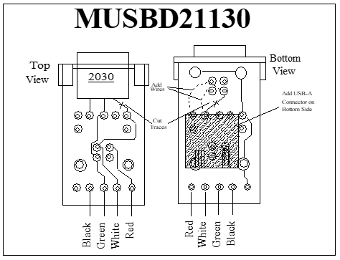
Figure 36. Modification of USB Adapter Module

6.0 Fabrication of 26-pin Adapter PWA

6.1 Solder 26-pin wire-wrap connectors, CW Industries P/N CWN-370-26-0000, to 3” x 2” breadboard, Vector Electronics P/N 8029.

6.2 Attach wire-wrap wires between the connectors as follows:

J1 J2 J1 J2
Pin 1 Pin 2 Pin 14 Pin 13
Pin 2 Pin 1 Pin 15 Pin 16
Pin 3 Pin 4 Pin 16 Pin 15
Pin 4 Pin 3 Pin 17 Pin 18
Pin 5 Pin 6 Pin 18 Pin 17
Pin 6 Pin 5 Pin 19 Pin 20
Pin 7 Pin 8 Pin 20 Pin 19
Pin 8 Pin 7 Pin 21 Pin 22
Pin 9 Pin 10 Pin 22 Pin 21
Pin 10 Pin 9 Pin 23 Pin 24
Pin 11 Pin 12 Pin 24 Pin 23
Pin 12 Pin 11 Pin 25 Pin 26
Pin 13 Pin 14 Pin 26 Pin 25

6.3 Trim the wire-wrap leads to approximately 1/4”.
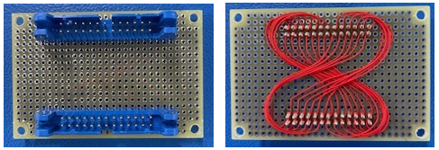
Figure 37. 26-pin Adapter PWA

7.0 Installation of Test Fixture Base Sub-assemblies

7.1 Bottom panel assembly

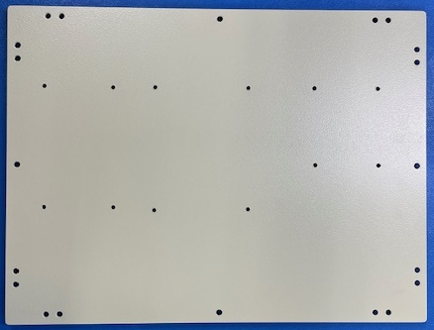
Figure 38. Drilled Bottom Panel View

7.1.1 Mount S2 Test PWA to bottom panel using the following hardware: 4 each 6-32 1/2” female to female threaded hex standoffs, 8 each 6-32 3/8” screws, 8 each #6 flat washers and internal tooth lock washers.

7.1.2 Mount SAM-E PWA to bottom panel using the following hardware: 4 each 6-32 1/2” female to male threaded hex standoffs, 4 each 6-32 3/8” screws, 4 each #6 flat washers and internal tooth lock washers, 4 each 6-32 locknuts w/external tooth lock washers.

7.1.3 Mount 24VDC Power Supply Module to bottom panel using the following hardware: 4 each 6-32 1/2” female to female threaded hex standoffs, 8 each 6-32 3/8” screws, 8 each #6 flat washers and internal tooth lock washers.

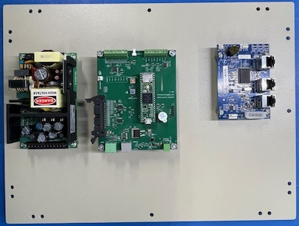
Figure 39. Assembled Bottom Panel

7.2 Rear panel assembly

7.2.1 Install AC entry module using the following hardware: 2 each, 3/8” 4-40 flat head screws, #4 flat washers and internal tooth lock washers.

7.2.2 Install panel mount USB adapter module, (modified per drawing TE-M1-3200-6), using hardware supplied with module.

7.2.3 Install panel mount Ethernet connector using hardware supplied with connector.

7.2.4 Install 26-pin adapter PWA using the following hardware: 4 each 3/8” 6-32 screws, #6 flat washer and internal lock washer, 1/2” male to female 6-32 hex standoffs, and 6-32 locknuts w/external tooth lock washers.

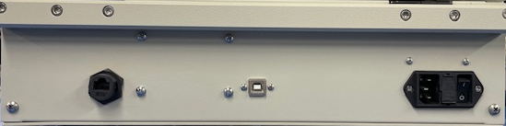
Figure 40. Assembled Rear Panel

7.3 Front panel assembly

7.3.1 Install panel mount LED using hardware supplied with LED.

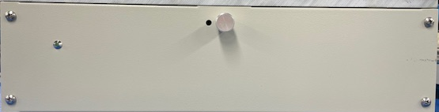
Figure 41. Assembled Front Panel

8.0 Test Fixture Base, Assembly Instructions

8.1 Re-assemble test fixture base, using hardware that was removed during disassembly.

8.2 Secure side panels to front panel using 4 screws.

8.3. Secure rear panel using 2 lower screws.

8.4 Secure bottom panel using 12 screws.

8.5 Secure rear support bar and rear probe plate hinges.

8.6 Install the AC entry module cover bracket using the following hardware: 3 each 4-40 3/8” screws, flat washers, internal tooth star washers, and nuts.

9.0 Wiring of Test Fixture Base Modules

9.1 AC entry module to power supply module connections

9.1.1 Remove right side nut and washers from AC entry module and place the AC entry module cable’s green wire ring terminals over the screw. Replace washers and nut.

9.1.2 Plug the female disconnect lug from the green wire onto the ground lug of the AC entry module.

9.1.3 Plug the female disconnect lug from the white wire onto the neutral lug of the AC entry module.

9.1.4 Plug the female disconnect lug from the black wire onto the line lug of the AC entry module.

9.1.5 Plug the 5 pin AC entry module cable connector into the AC input connector on the power supply module.

9.2 Power supply module output to S2 Test PWA and SAM-E PWA connections

9.2.1 Plug the 13 pin power supply out cable connector into the power supply output connector.

9.2.2 Plug the 2 pin power supply output cable connector into the S2 Test PWA J12 connector, Power-in 12V/2A.

9.2.3 Plug the 5 pin power supply output cable connector into the SAM-E J07 connector, 5V Power.

9.2.4 Insert the crimp connector, on the red wire of the panel mount LED, onto pin 5 of the power supply module output connector (insert through the connector body).

9.2.4 Install 12” Ethernet cable between rear panel mount Ethernet connector and SAM-E connector, J12.

9.2.5 Using double sided tape, mount the USB hub to the inner front side of the test fixture base, 1” from the left side and centered vertically, with the input cable facing left.

9.2.6 Route USB cable from USB HUB, under the S2 Test PWA, and connect to panel mount USB connector. Attached cable tie mount under S2 Test PWA and secure USB cable with cable tie.

9.2.7 Connect USB A to USB micro cable between USB hub and Teensy daughter board on S2 Test PWA.

9.2.8 Connect the 26 pin ribbon cable, shown in Figure 32, between the S2 Test PWA, J5, and the bottom connector on the 26 pin adapter PWA.

9.2.9 Connect the black lead from the front panel LED into J1 pin 3 of S2 Test PWA.

10.0. Probe Plate Reassembly

10.1 Secure the left side probe plate spring hinge to the left side panel.

10.2 Secure the probe plate to the rear probe plate hinges.

10.3 Secure the probe plate spring hinges to the probe plate.

10.3 Secure the probe plate latch.

11.0 Installation of Probe Sockets and Alignment Pins

11.1 Install alignment pins at mounting hole locations, MTG1 and MTG3 per probe plate drill chart Drill-M1-3200-1.

11.2 Install probe sockets at each location designated in the probe plate drill chart, drawing Drill-M1-3200-1.

11.2.1 Install 100 size probe sockets using installation tool, QA Technology AT100 set to 0.233” depth.

11.2.2 Install 075 size probe sockets using installation tool, QA Technology AT75 set to 0.233” depth.

11.3 Place each socket into the probe socket hole, insert the insertion tool into the socket, and tap lightly with a small hammer until the insertion tool is flush with the probe plate. Keep the insertion tool as close to vertical as possible during installation.

Note: If a probe socket gets damaged during installation, remove it by using extraction tool, QA Technology ETR100, for 100 size sockets or tool, QA Technology ETR075, for 075 size sockets, by pushing the socket though the probe plate, using a small hammer.

12.0 Wiring of Probe Sockets

12.1 Ethernet cable, SAM-E to J11

12.1.1 Connect the Ethernet cable wires from the prepped Ethernet cable (see Section 4.5) to the following probe sockets:

Wire color J11 socket pin
Green/white pin 1
Green pin 2
Orange/white pin 3
Blue pin 4
Blue/white pin 5
Orange pin 6
Brown/white pin 7
Brown pin 8

12.2 USB COM cable

12.2.1 Connect the USB COM cable wires from the prepped USB cable (see Section 4.6) to the following probe sockets:

Wire color Test point
Red TP113
White TP111
Green TP119
Black TP114

12.3 Panel LED cable

12.3.1 Insert 2 pin connector from Panel LED cable into J8 on the S2 Test PWA.

12.3.2 Route the wires to the probe sockets at locations J02.1 and J02.2.

12.3.3 Wire-wrap J8 pin 1 to socket J02.1.

12.3.4 Wire-wrap J8 pin 2 to socket J02.2.

12.4 Tamper cable

12.4.1 Insert 2 pin connector from Tamper cable into J8 on the S2 Test PWA.

12.4.2 Route the wires to the probe sockets at locations J08.1 and J08.2.

12.4.3 Wire-wrap J9 pin 1 to socket J08.1.

12.4.4 Wire-wrap J9 pin 2 to socket J08.2.

12.5 Battery cable

12.5.1 Insert 2 pin connector from Battery cable into J10 on the S2 Test PWA.

12.5.2 Route the wires to the probe sockets at locations J07.1 and J07.2.

12.5.3 Wire-wrap J10 pin 1 to socket J07.1.

12.5.4 Wire-wrap J10 pin 2 to socket J07.2.

12.6 Power cable

12.6.1 Insert 2 pin connector from Battery cable into J11 on the S2 Test PWA.

12.6.2 Route the wires to the probe sockets at locations J06.1 and J06.2.

12.6.3 Wire-wrap J11 pin 1 to socket J06.1.

12.6.4 Wire-wrap J11 pin 2 to socket J06.2.

12.7 Wires to S2 Test PWA, J1

12.7.1 Connect wires from the S2 Test PWA, J1, to the following probe sockets:

J1 pin Probe socket
7 J27 pin 2
8 J27 pin 1

12.8 Wires to S2 Test PWA, J6

12.8.1 Connect wires from the S2 Test PWA, J6, to the following probe sockets:

J6 pin Probe socket
1 J14 pin 1
2 TP025
3 TP36
4 TP31
5 TP34
6 TP35
7 TP33
8 P3 pin 2

12.9 Other connections to probe sockets

12.9.1 USB cable, Adafruit P/N 4449, to Flash drive

12.9.1.1 Connect the flash drive into the USB cable.

12.9.1.2 Connect the header end of the USB cable to following J12 probe sockets as follows (see Figure 42):

Wire color Probe socket
Red J12 pin 1
White J12 pin 2
Green J12 pin 3
Black J12 pin 4

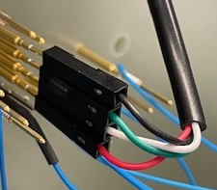
Figure 42. Flash Drive USB connections

12.9.2 USB cable to USB Hub

12.9.2.1 Connect the USB end of the USB cable to the USB Hub.

12.9.2.2 Connect the header end of the USB cable to following J25 probe sockets as follows (see Figure 43):

Wire color Probe socket
Black J05 pin 1
Brown J05 pin 2
Red J05 pin 3
Orange J05 pin 4
Yellow J05 pin 5
Green J05 pin 6

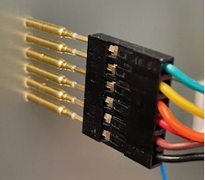
Figure 43. J25 USB HUB connections

12.9.3 26-pin ribbon cable

12.9.3.1 Connect 10” 26-pin ribbon cable to the 26-pin Adapter PWA and the J05 connector probe sockets as shown in Figure 44.

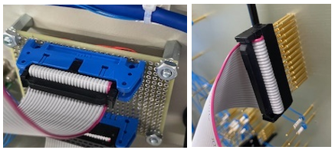
Figure 44. 26-pin Ribbon Cable Installation, Adapter PWA to Probe Sockets

12.10 Route wires and cabling neatly and secure with tie wraps and tie wrap mounts as needed.

13.0 Stripper Plate Reassembly

13.1 Installation of PCB board stops

13.1.1 Install 0.155” PCB boards stops into each hole as designated in stripper plate drill chart, using a small hammer.

13.2 Stripper plate switch assembly installation

13.2.1 Enlarge right side stripper plate alignment hole to 1/4”.

13.2.2 Cut 2-1/2” length of 3/8” diameter heat-shrink tubing.

13.2.3 Slide shrink tubing 2” from switch body and shrink.

13.2.4 Install switch onto switch bracket using the following hardware: 2 each 2-56 1/2” screws, #2 flat washers and lock washers, 2-56 nut.

13.2.5 Install switch bracket onto stripper plate using the following hardware: 2 each 4-40 3/8” screws, 4-40 locknuts w/external tooth lock washers.

13.2.6 Slide switch wires through the right-side stripper plate alignment hole.

13.2.7 Place the stripper plate springs into the depressions on the probe plate.

13.2.8 Slide switch wires through the right-side probe plate alignment hole and set the stripper plate in place on the probe plate.

13.2.9 Mount the stripper plate onto the probe plate using the knurled nuts that were removed during disassembly.

13.2.10 Insert the switch wires into pins 1 and 2 contacts, on connector J1 of the S2 Test PWA (wires are interchangeable).

13.2.11 Secure the wires by tightening the contact screws.

13.0 Push plate re-assembly

13.1 Install 1” long pressure fingers into each hole in the bottom side of the push plate, using a small hammer. Be careful to avoid sideways pressure onto the pressure fingers, as they can easily snap off.

13.2 Mount the push plate to the CAM assembly in the reverse order as described in Section 1.2. Be careful not to damage the pressure fingers during installation.

14.0 Installing CAM Over-clamp Assembly to Test Fixture Base

14.1 Re-install the gas hinge blocks (see Section 1.4.3).

14.2 Re-install the hinge blocks (see Section 1.4.2).

14.3 Re-install the latch blocks (see Section 1.4.1).

14.4 Re-install the CAM over-clamp hinges (see Section 1.1.2).

14.5 Secure the CAM over-clamp assembly to the CAM over-clamp hinges.

14.5 Re-install the gas hinges to the CAM over-clamp (see Section 1.1.1).

15.0 Fixture Engagement Switch Adjustment

15.1 Place a sample PWA into the test fixture and close the engagement lever.

15.2 Observe engagement switch for proper positioning.

15.3 Verify proper switch closure by measuring the resistance at S2 Test PWA, J1 pin 2 to 3.

15.4 If necessary, adjust the switch position by loosening the 2-56 screws and reposition it to achieve proper closure.

16.0 AC Entry Module Cover Installation

16.1 Cut 3 pieces of double-sided tape to 1/4”.

16.2 Place one piece of tape on the short side of the AC entry module cover backet, and 2 pieces on the long side.

16.3 Place the AC entry module cover onto the bracket and press firmly to secure it to the bracket.

Revision History
Date Version Reason/Description Author
5/8/24 draft Initial Release T. Newman

